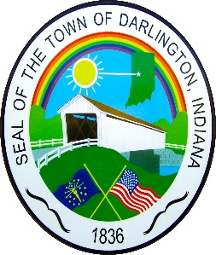 DARLINGTON TOWN COUNCIL MEETING

COMMUNITY CENTER

105 SOUTH FRANKLIN STREET

DARLINGTON, INDIANA 47940

THURSDAY, SEPTEMBER 4, 2025 AT 5:00 P.M

LIVESTREAM ON YOUTUBE – Town of Darlington Council

I. CALL TO ORDER

1. Pledge

PUBLIC COMMENT

II. APPROVAL OF MINUTES

Regular Meeting – August 7, 2025

III. MONEY MATTERS

1. Appropriations Report

2. Payroll Docket

3. Revenue Report

4. Transfer for $6,000.00 from 2201001311.000 – Resurfacings to 221001440.000 Machinery & Equipment for a new

salt spreader.

5. Transfer for $700.00 from 2211000362.000 materials to 2211001210.000 supplies for bill to pay supplies for John

Deere.

IV. NEW BUSINESS

1. First Reading of Ordinance 4-2025 Town of Darlington 2026 Budget

VI. OLD BUSINESS

1. 2026 Raises (Matrix)
2. Community Center Future

VIII STAFF & ELECTED OFFICIALS REPORTS – (LIASON REPORTS)

1 Attorney Report – Tyler Nichols

2. Wastewater Report – UMAC – Troy Elles

3. Electric Report – Jason Gates/Brian Mullen

4. MVH Report - Brian Mullen -Business/Truck Signs

5. Town Marshal Report – Kevin Crull- Monthly Schedule, Activity Log

6. Park -Bob Cash

7. Code Enforcement Officer –Mike Smith

8. Clerk-Treasurer – Michelle Cash – billing report – billing message

IX. DARLINGTON TOWN COUNCIL MEMBERS:

ELECTED – 4 YEAR TERM – 01/01/24-12/361/27

1. Nicole Parker – President
2. Teresa Sutherlin – Vice President
3. Jeremy Weliever -Council
4. Jennifer Flaugher - Council

5. Marilyn Cohee - Council

X. PUBLIC COMMENT

XI. INSERT – Next Scheduled Meeting – September 18, 2025 -5:00 p.m. – 2026 Budget Adoption Meeting

October 2, 2025 – 5:00 p.m. - Regular Meeting

XII. ADJOURN Agenda subject to change

Ordinance –5- 2025

Resolution – 4-2025