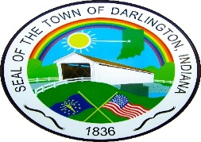 DARLINGTON TOWN COUNCIL SPECIAL MEETING

COMMUNITY CENTER

105 SOUTH FRANKLIN STREET

DARLINGTON, INDIANA 47940

THURSDAY, AUGUST 28, 2025 AT 8:30 A.M

LIVESTREAM ON YOUTUBE – Town of Darlington Council

I. CALL TO ORDER

1. Pledge

PUBLIC COMMENT

II. APPROVAL OF A BEER GARDEN AT THE DARLINGTON PARK ON SEPTEMBER 6TH & 7TH AT THE

DARLINTON FESTIVAL.

III. OTHER BUSINESS

IV. DARLINGTON TOWN COUNCIL MEMBERS:

ELECTED – 4 YEAR TERM – 01/01/24-12/361/27

1. Nicole Parker – President
2. Teresa Sutherlin – Vice President
3. Jeremy Weliever -Council
4. Jennifer Flaugher - Council

5. Marilyn Cohee - Council

V. PUBLIC COMMENT

VI. INSERT – Next Scheduled Meeting – September 18, 2025 -5:00 p.m. – 2026 Budget Adoption Meeting

October 2, 2025 – 5:00 p.m. - Regular Meeting

VII. ADJOURN Agenda subject to change

Ordinance –5- 2025

Resolution – 4-2025